# Responsibilities of the network layer

How a machine in network(A1,A2,A3,A4) can communicate with a machine in different network(B1,B2,B3,B4).

1. Communication 🡪 Host to Host (source to destination)
2. logical IP 🡪 Network and Host
3. Routing

# **Class ‘A’ in IP addressing**

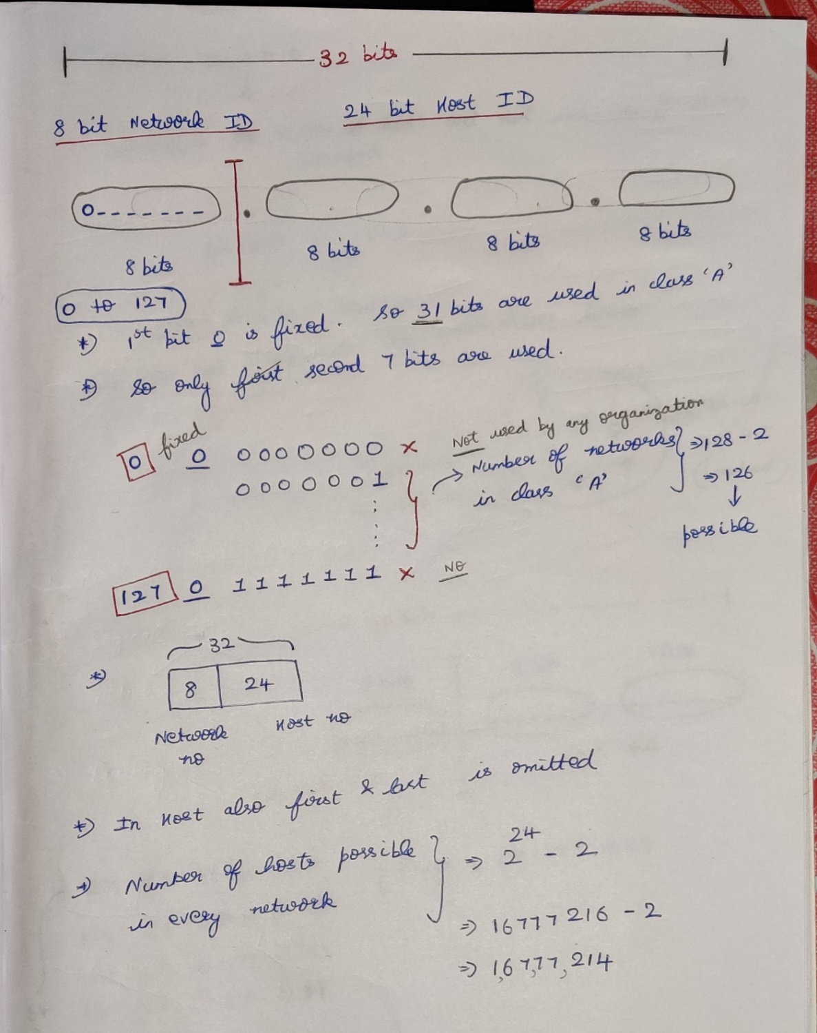  
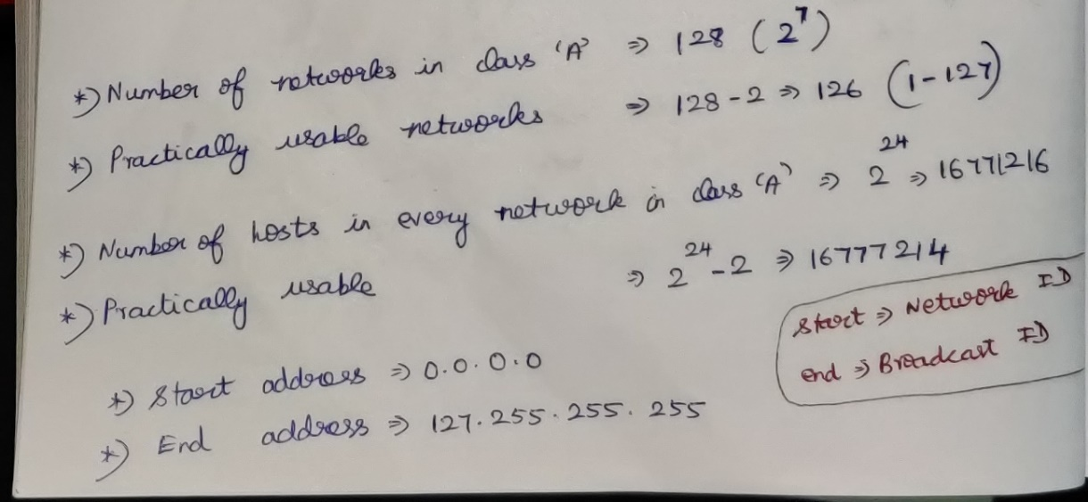

## Question

Suppose 64.0.0.0 is the IP address allotted to Google, What is the last address of this IP?  
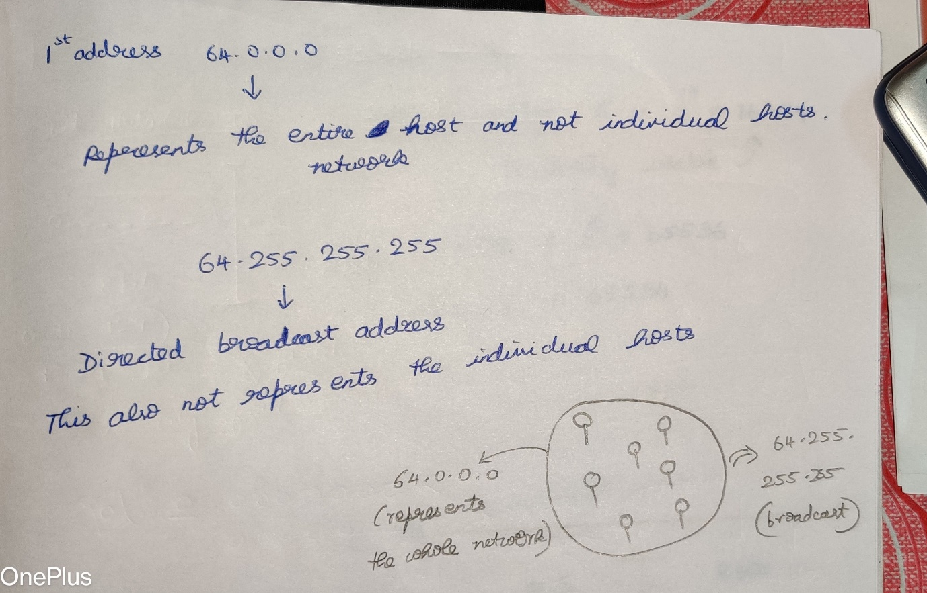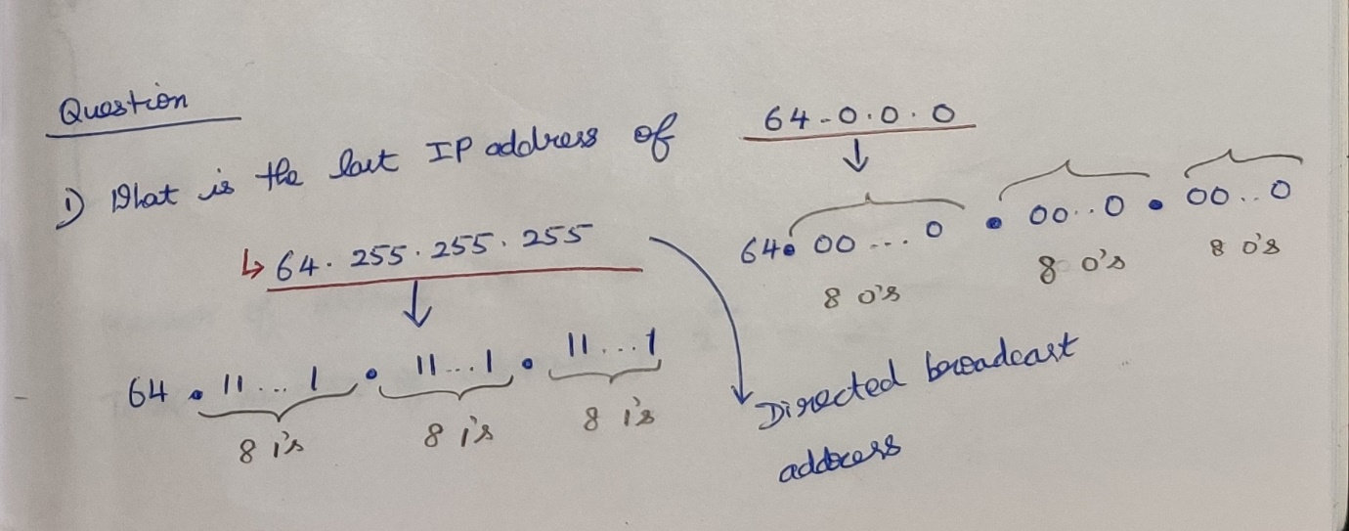

## Question

Ip 64.0.0.0 comes under which network??

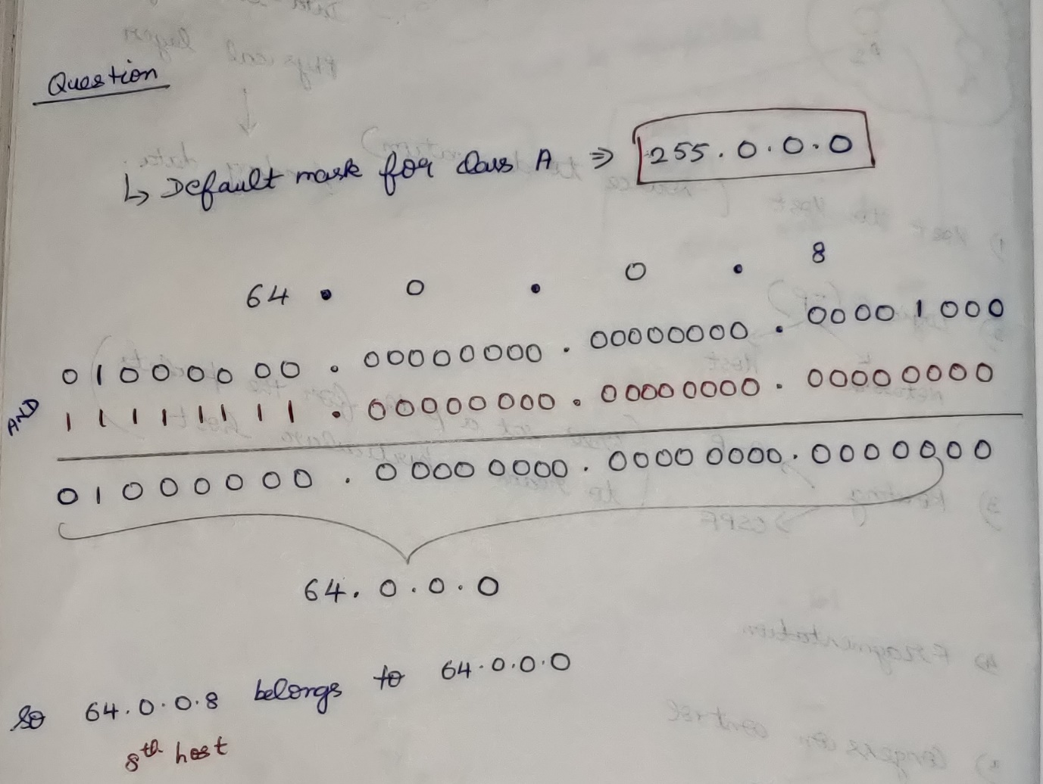

# **Class ‘B’ in IP addressing**

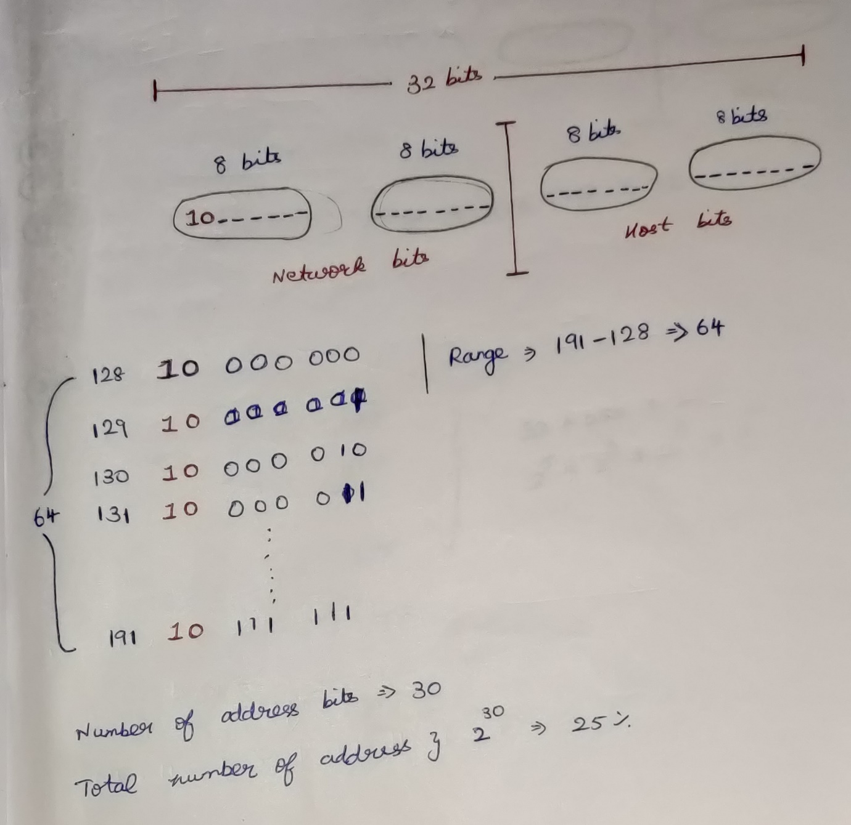  
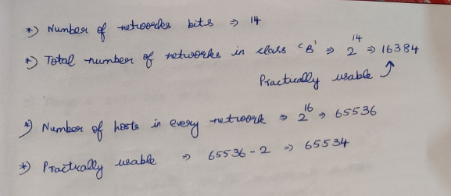

# **Class ‘C’ in IP addressing**

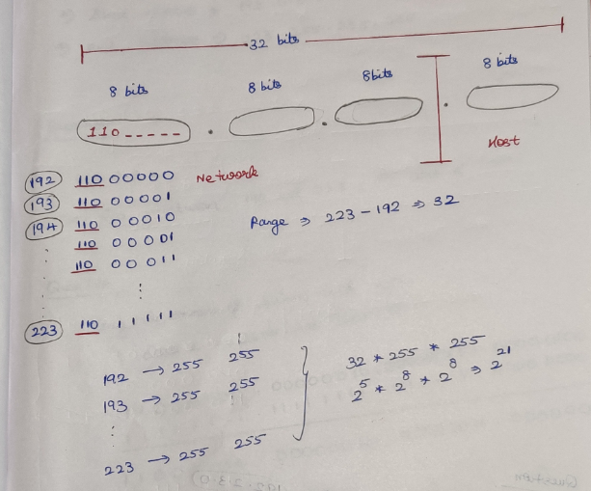  
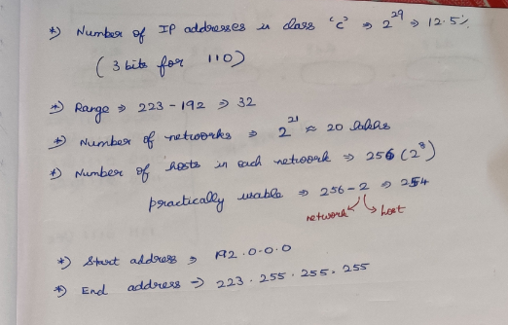

## **Question**

TO which class does IP 192.2.3.4 belongs to?

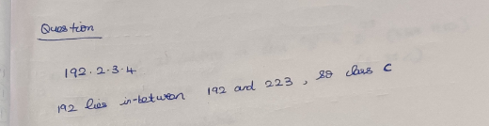

## **Question**

To which network does IP 192.2.3.4 belongs to?

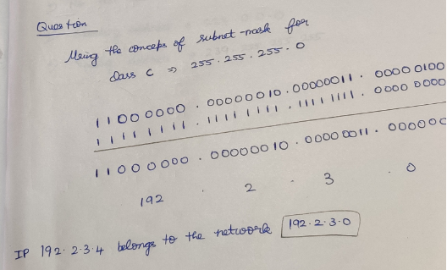

## **Question**

State the starting and ending address IP 192.2.3.4

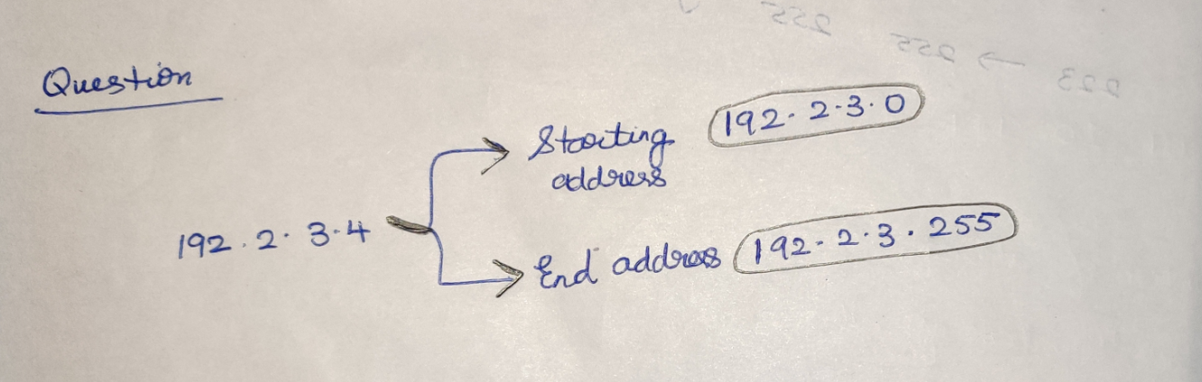

# **Class ‘D’ in IP addressing**

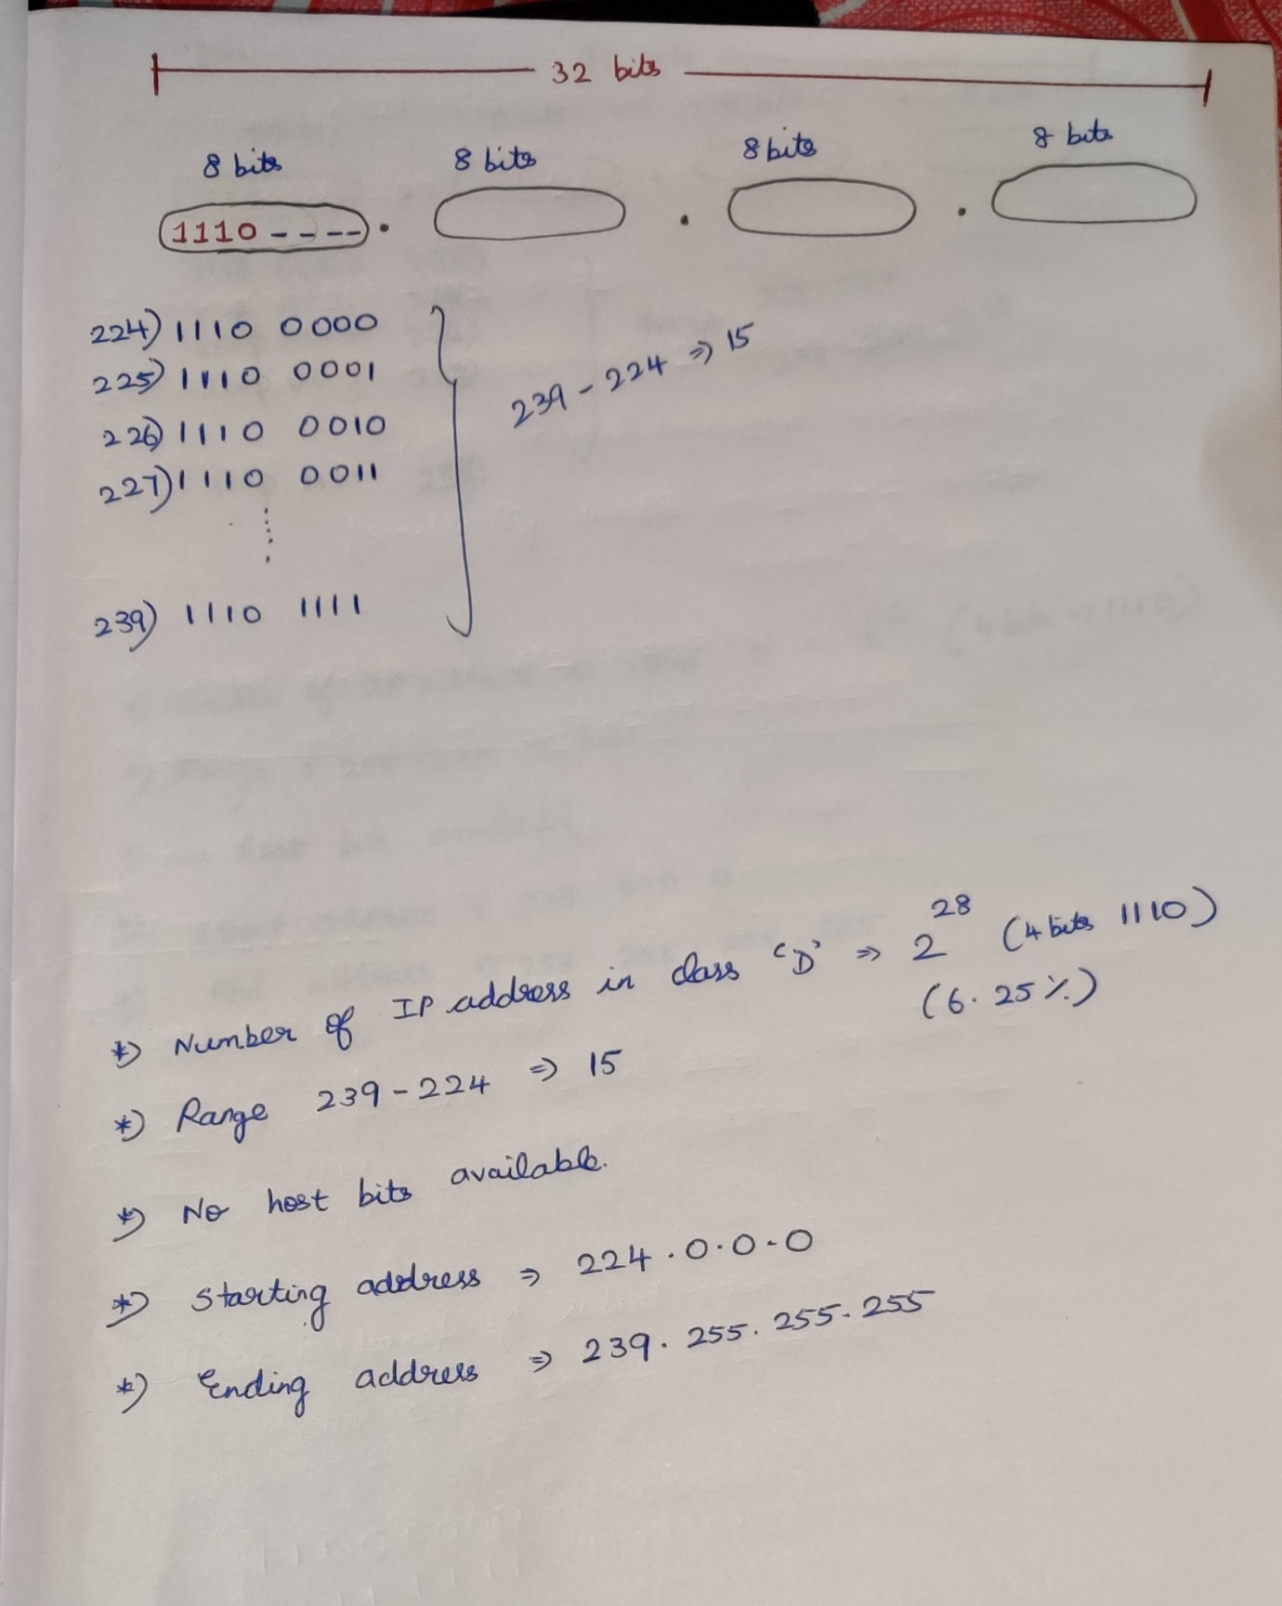

# **Class ‘E’ in IP addressing**

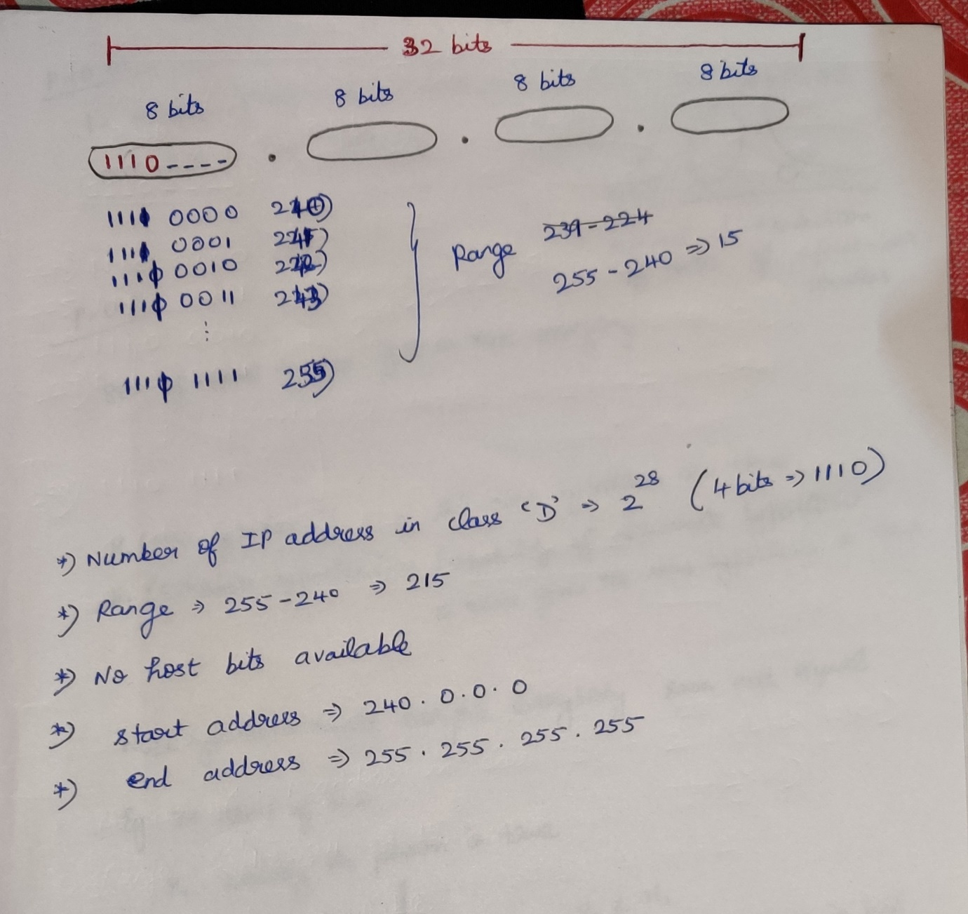

# **Question**

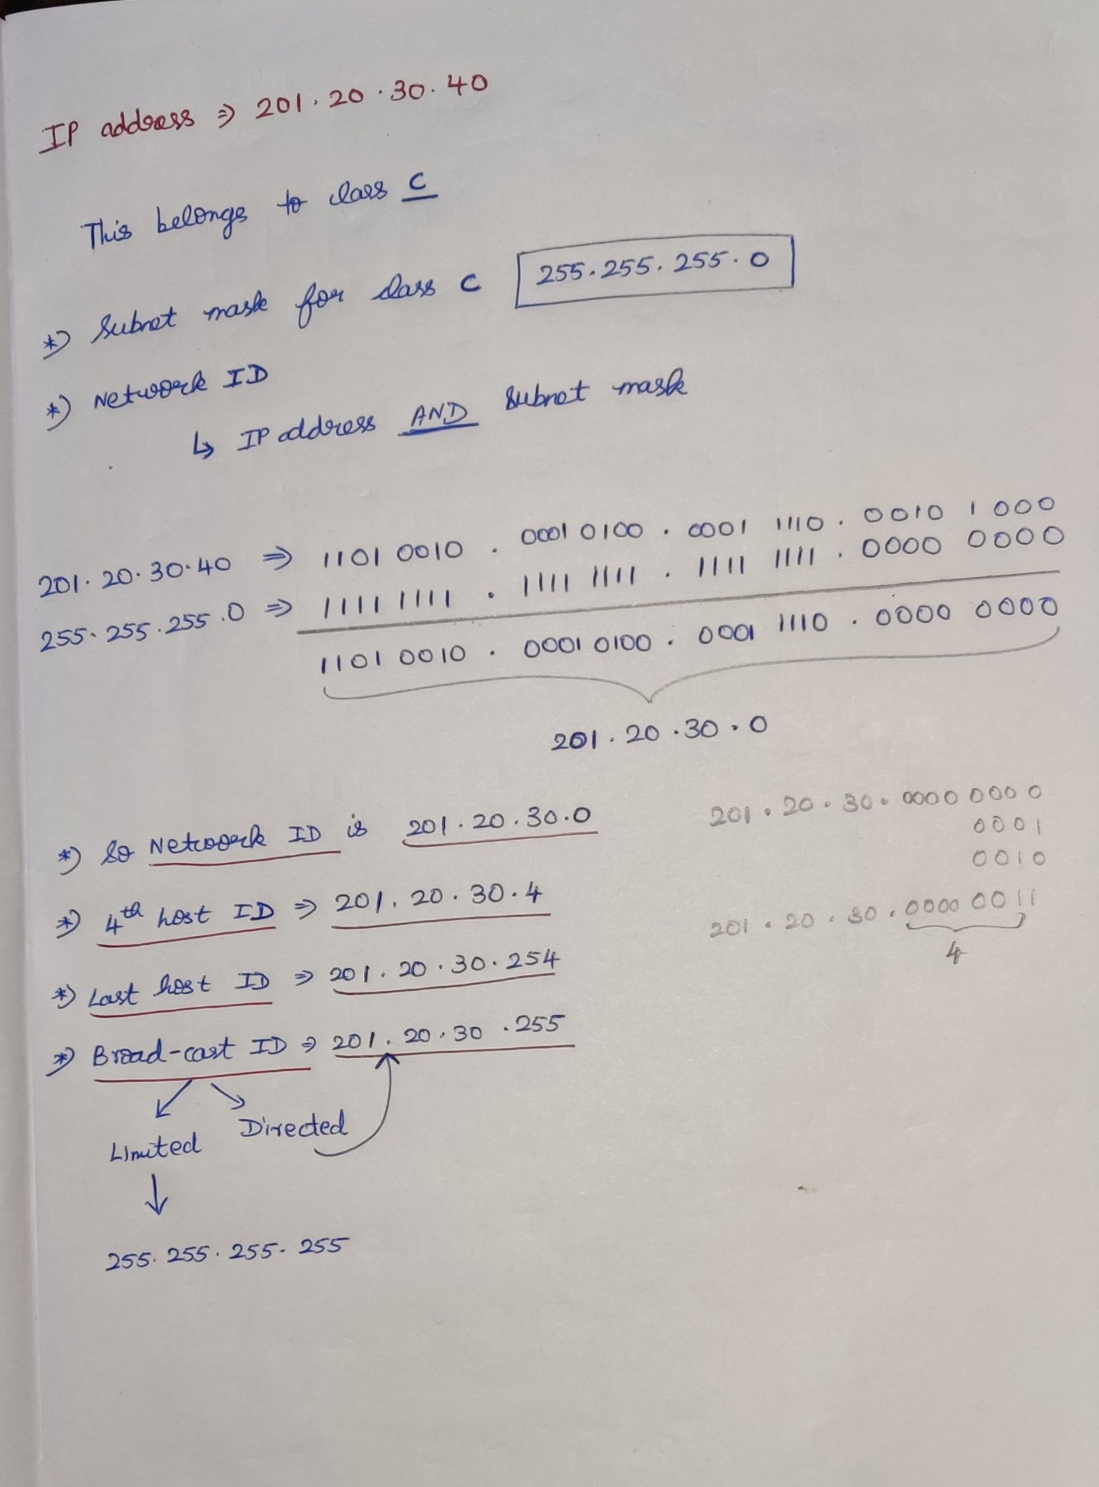

# **Problems in classful IP addressing**

# **Classless Addressing / Classless Inter Domain Routing [CIDR]**

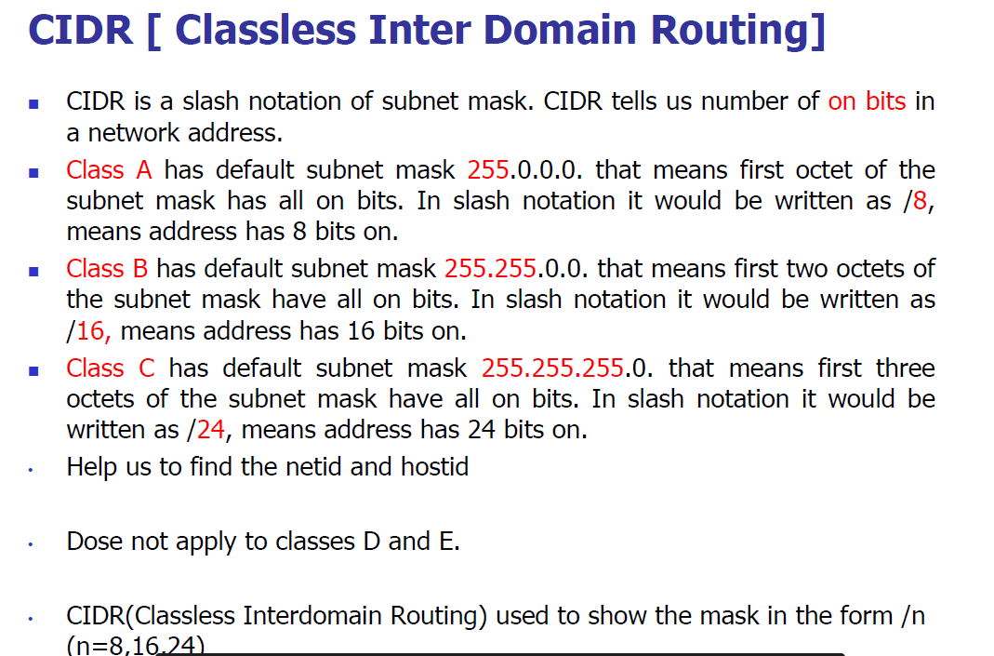

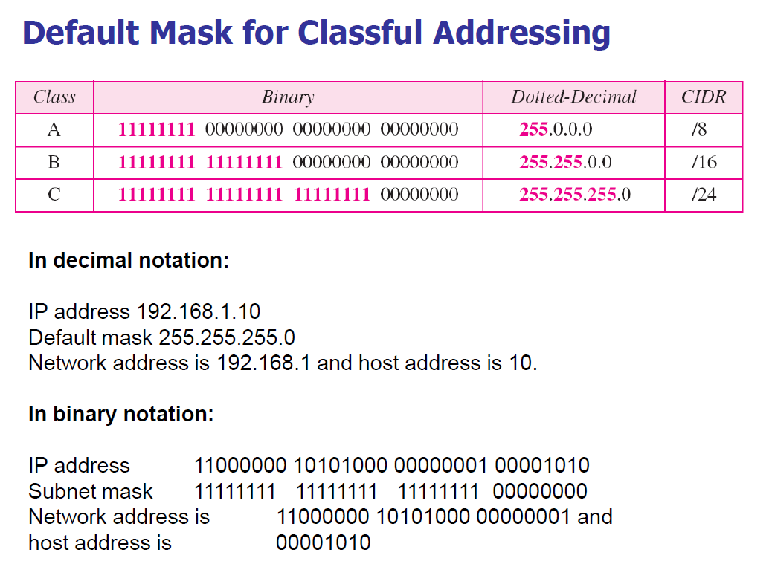

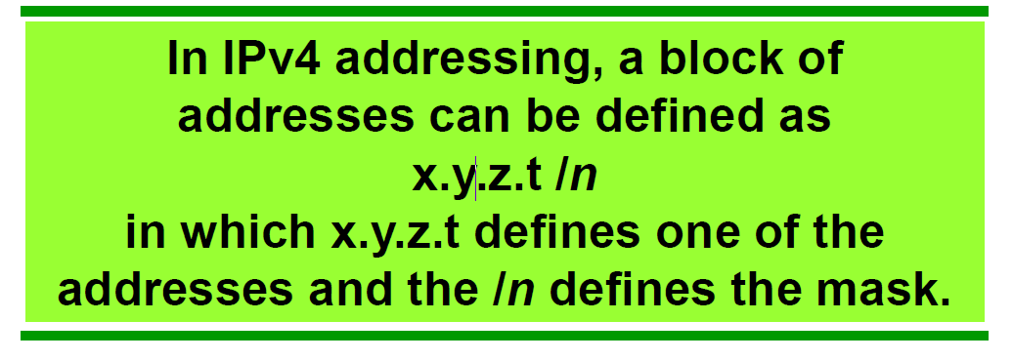  
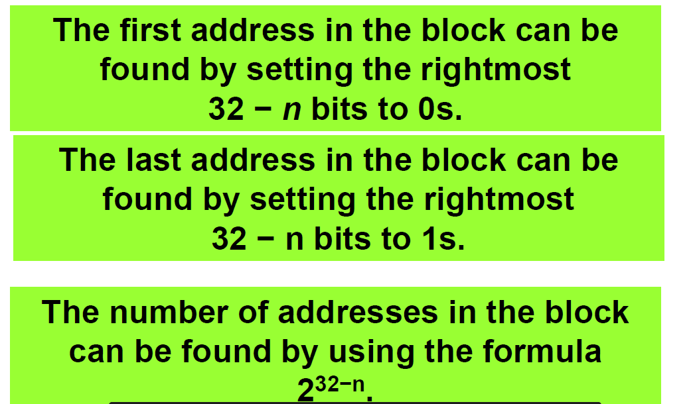

How to find the starting address for the IP address (Network ID) with mask

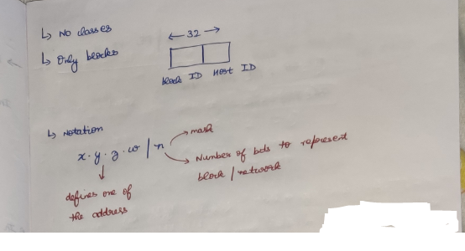

## **Method-1**

### **Question-1**

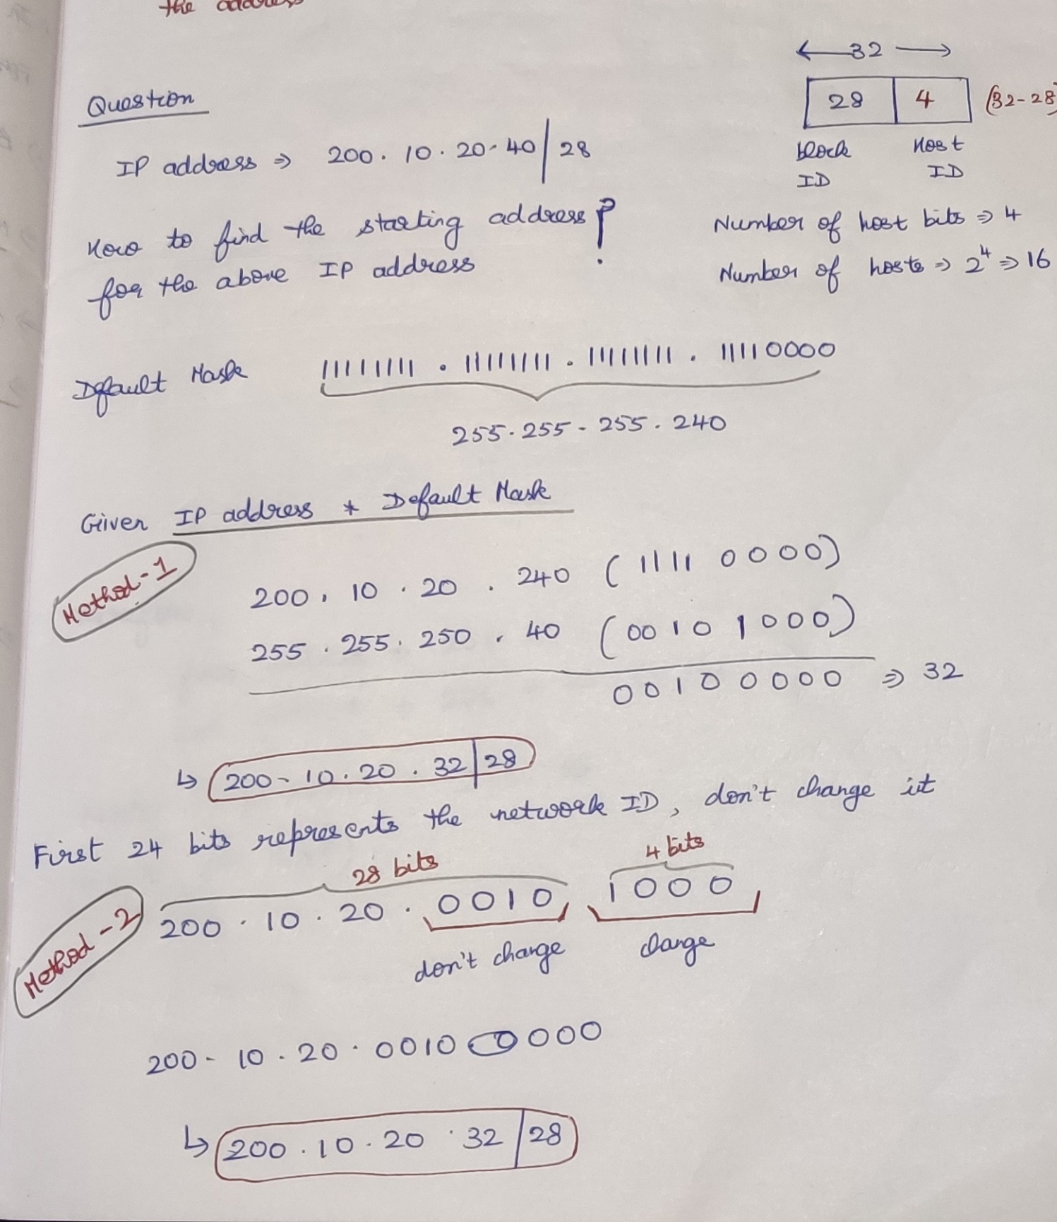

### **Question-2**

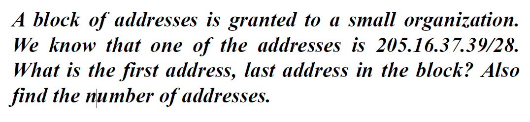

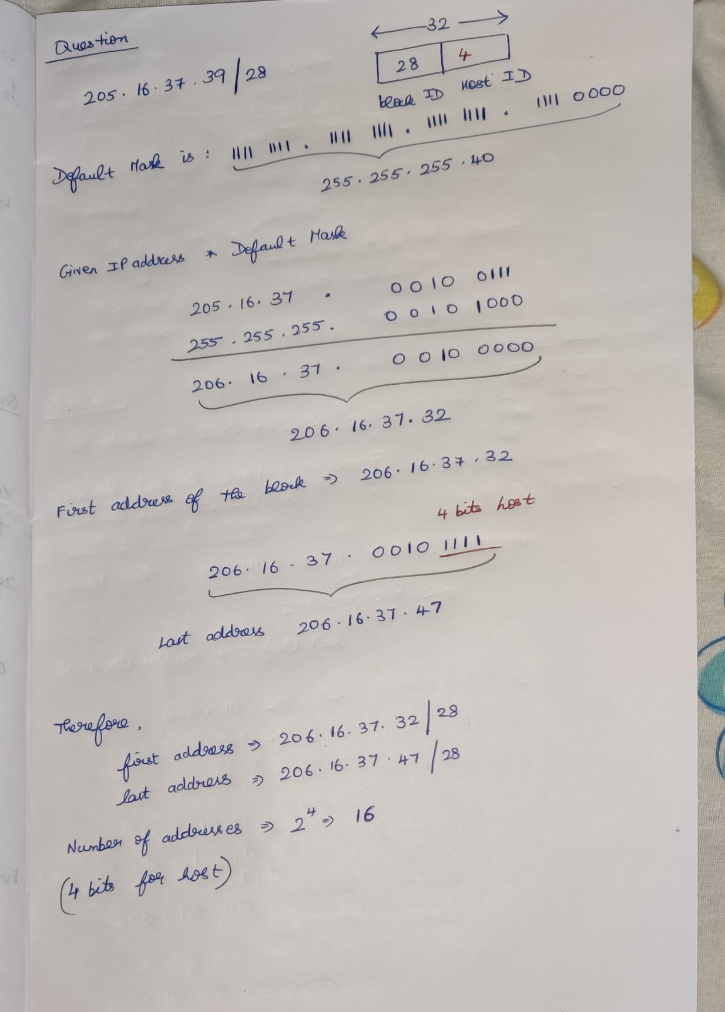

## **Method-2**

IP address AND Default MASK

### **Question-1**

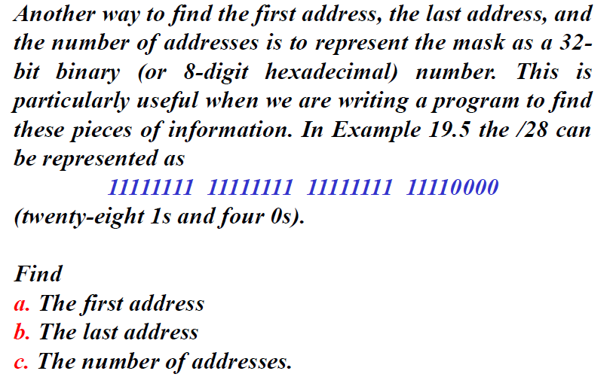

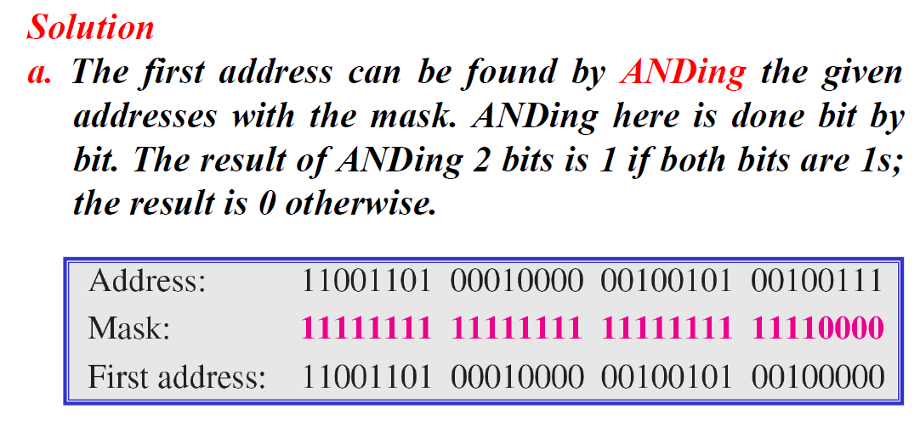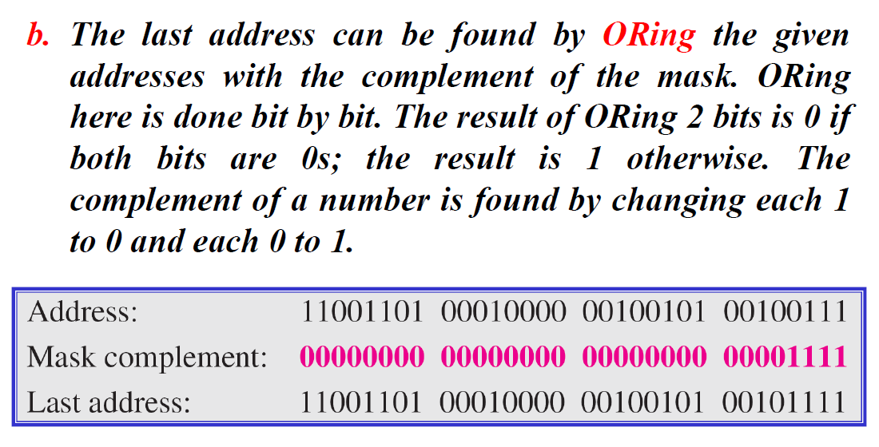

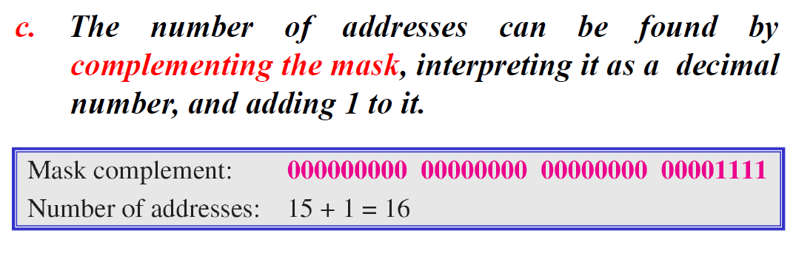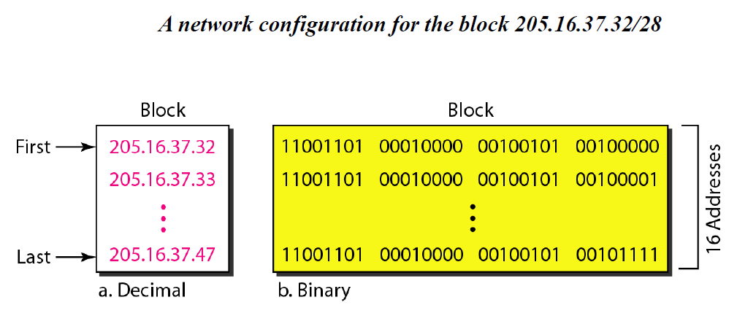

## **Rules**

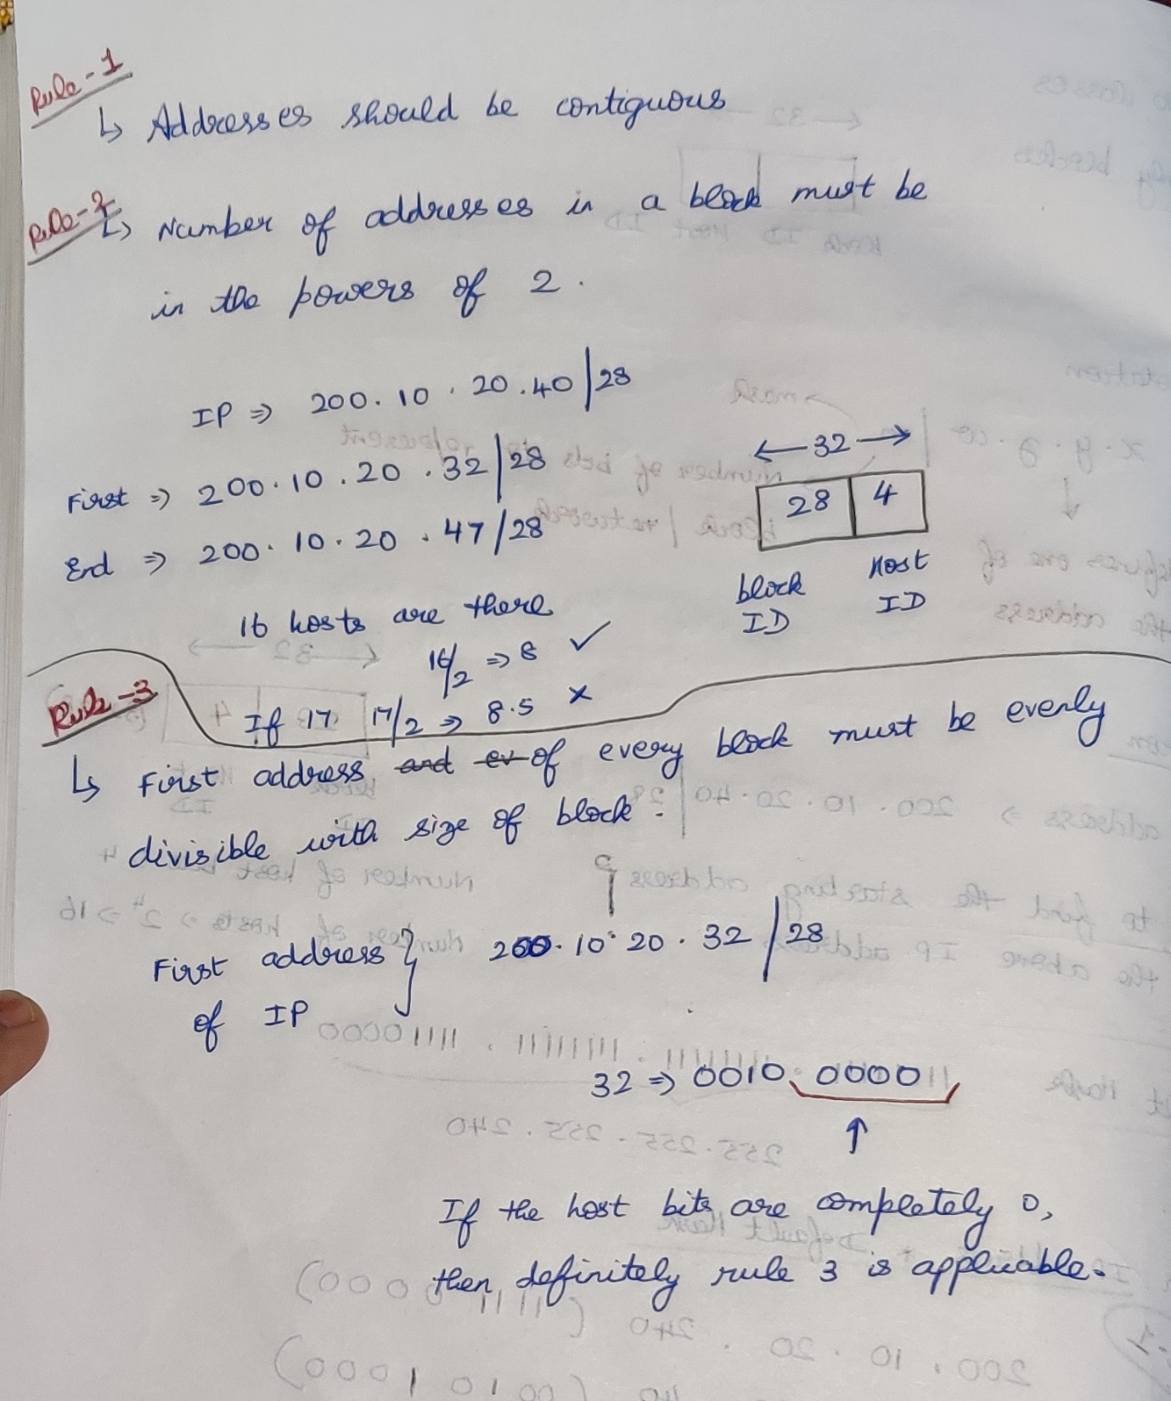

# **Subnet in Class-full Addressing**

What is subnetting   
Taking a large network and breaking it down, and treating them as separate networks  
Subnetting is borrowing a bit from the host part and create a network.

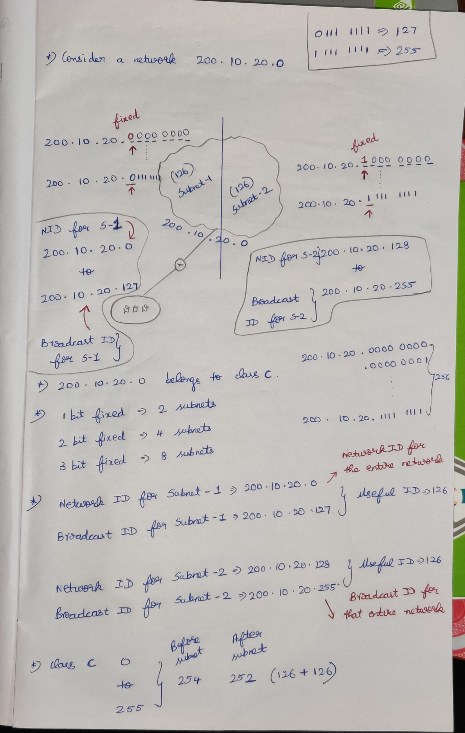

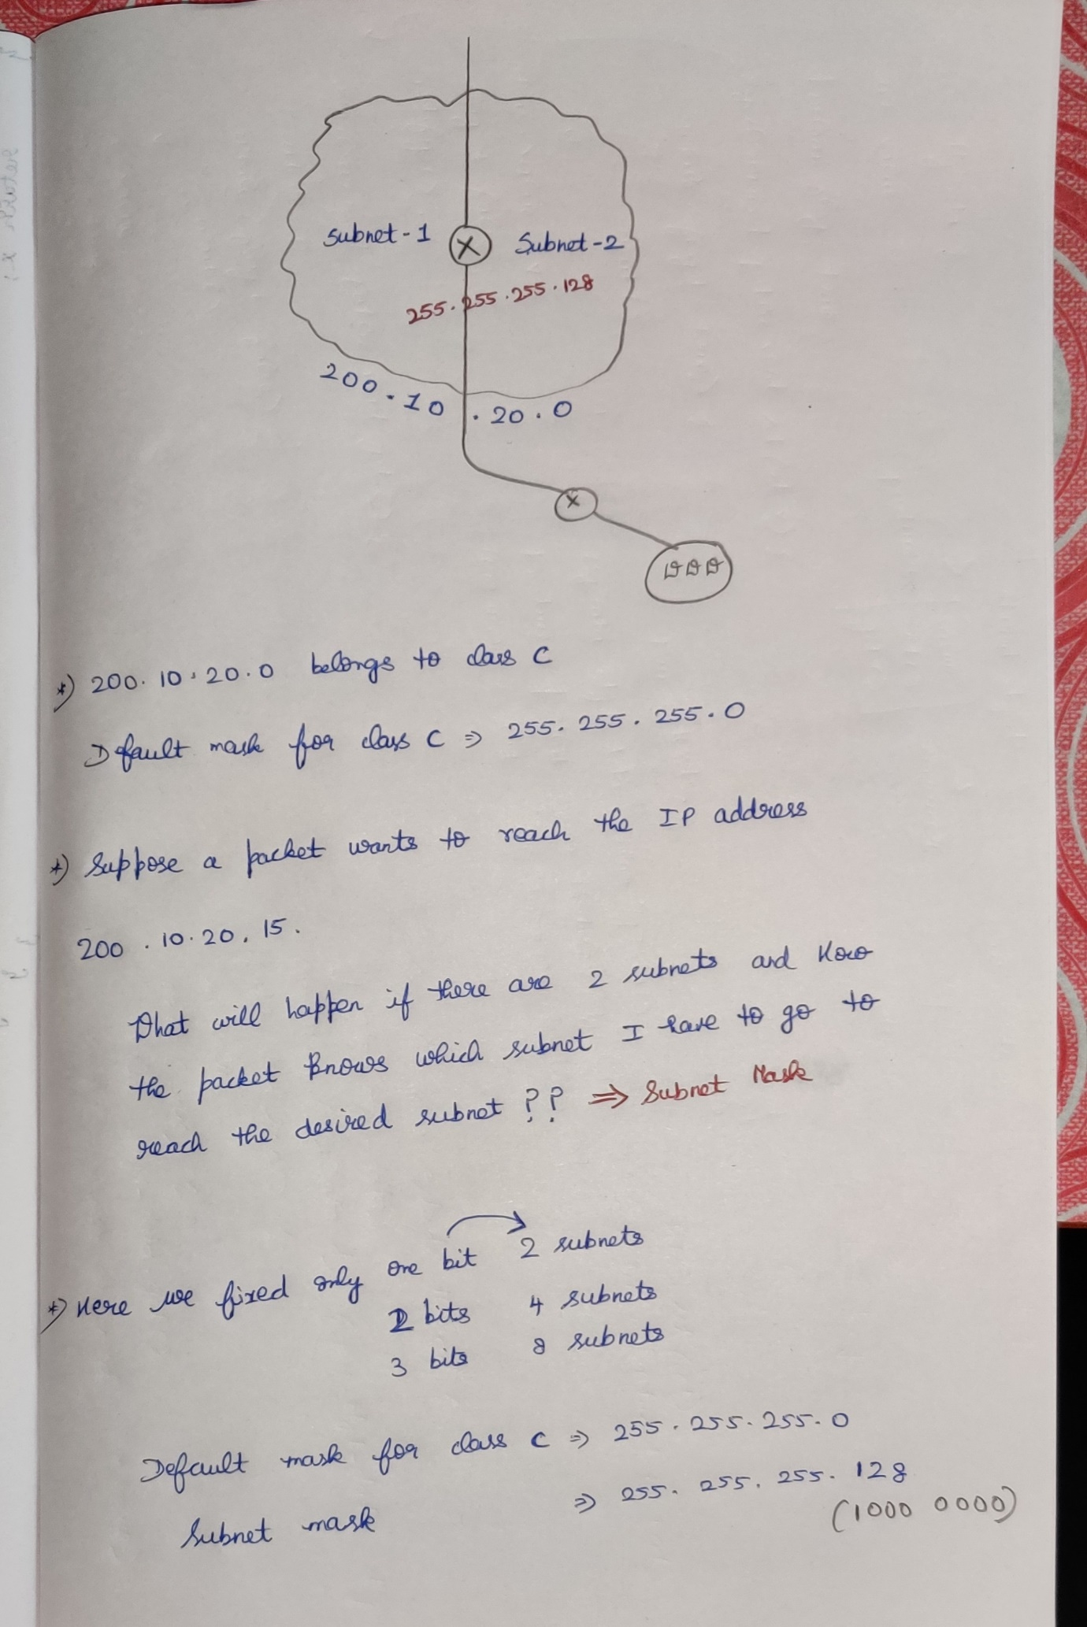

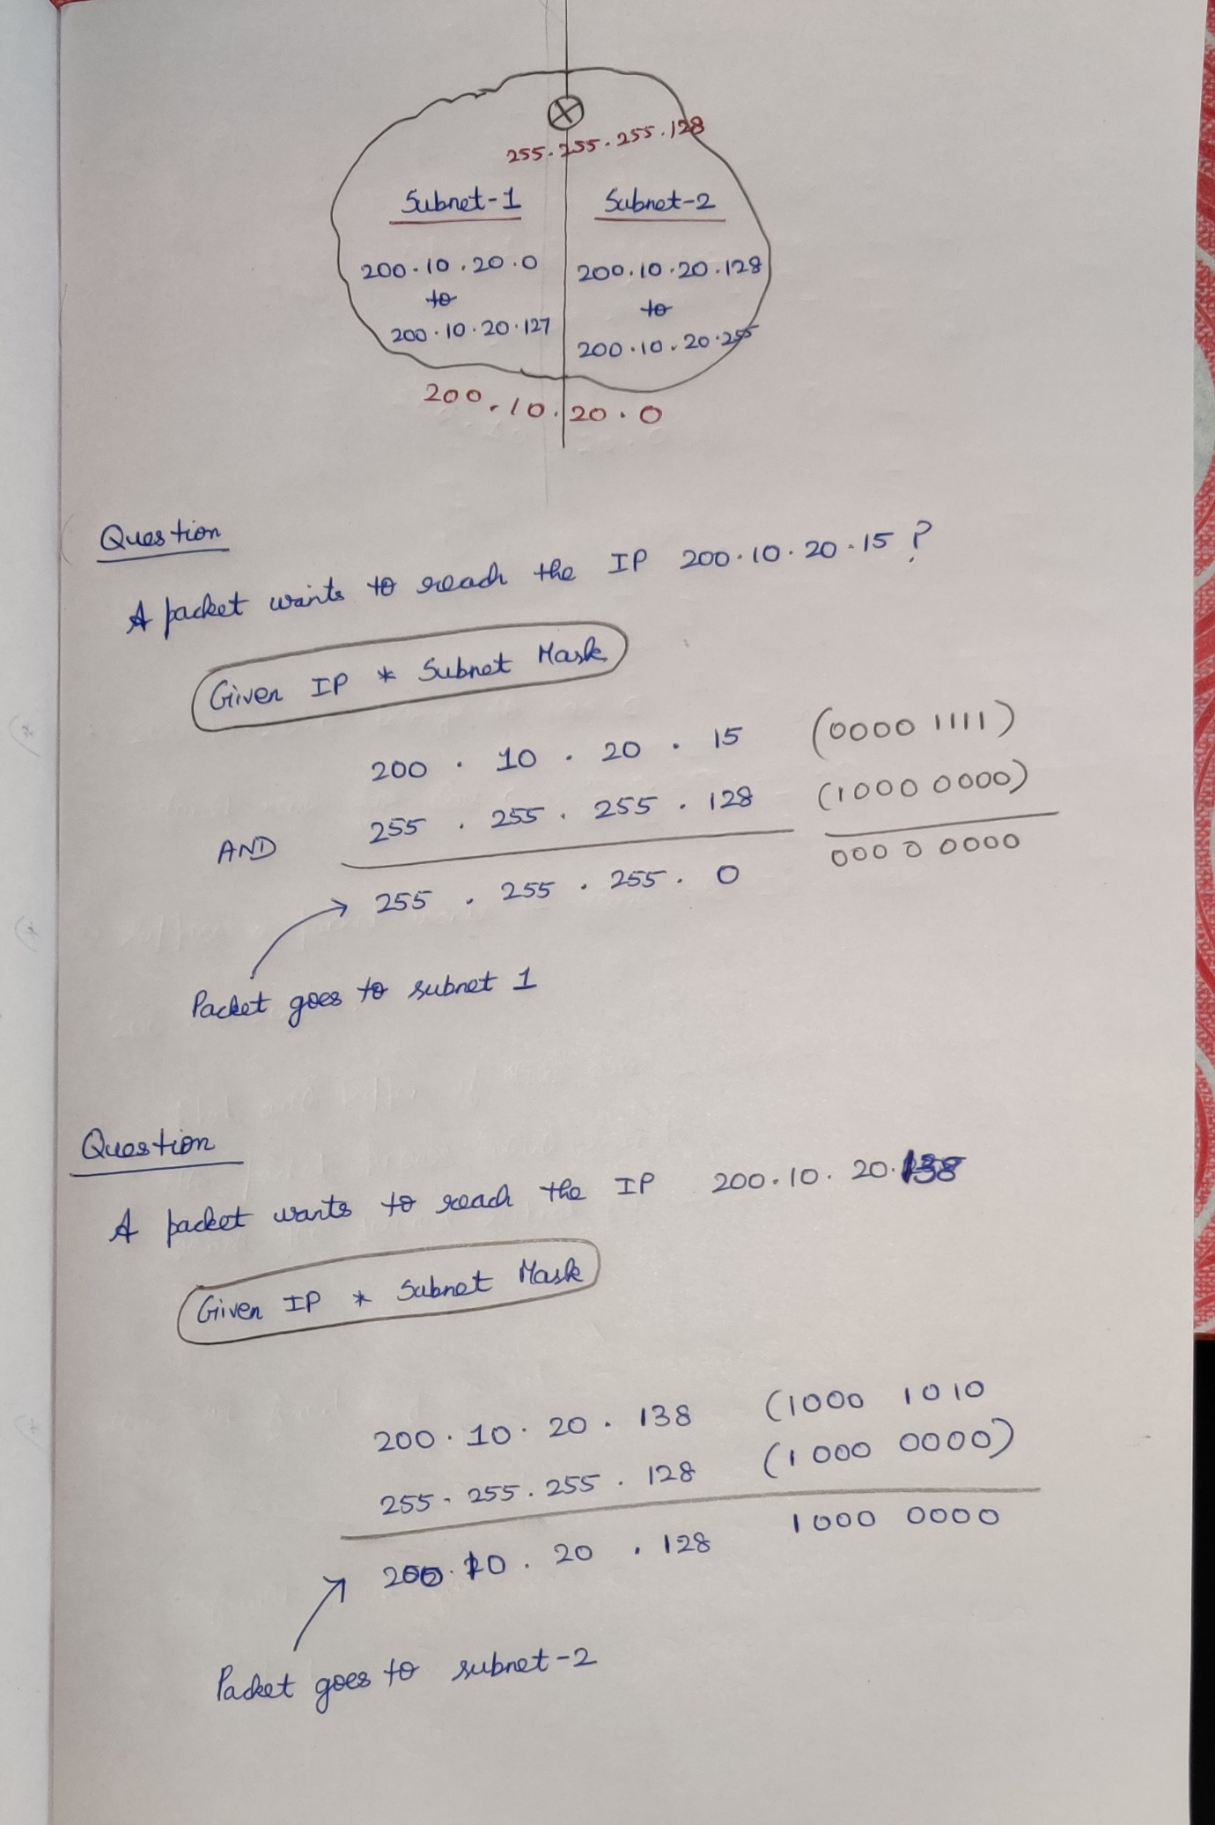

## Question-1

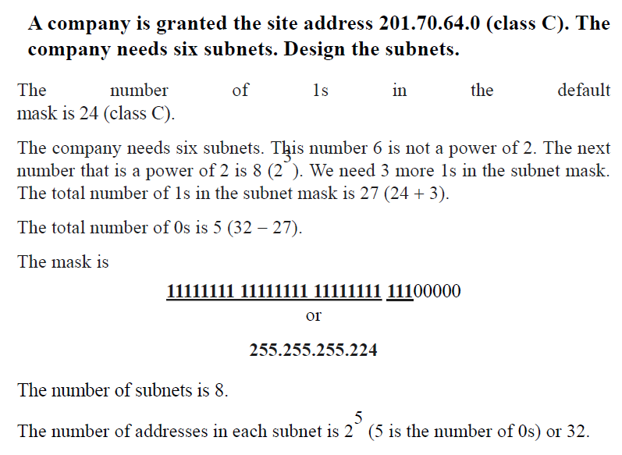

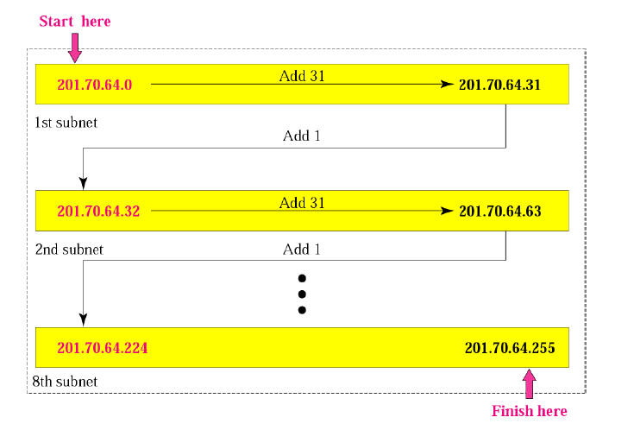

## Question-2

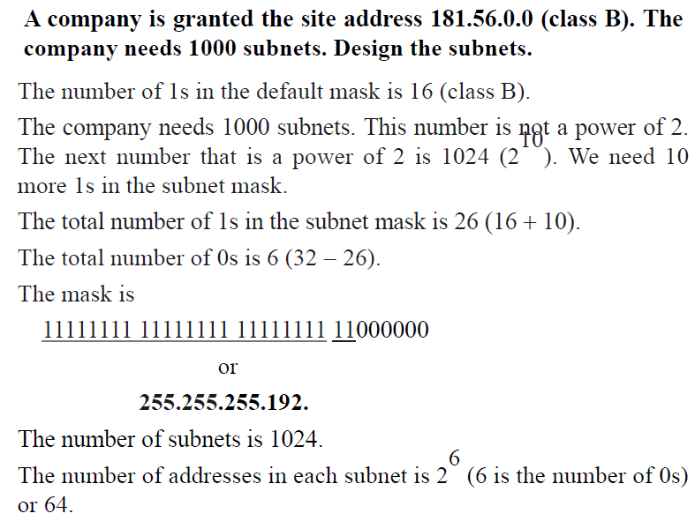

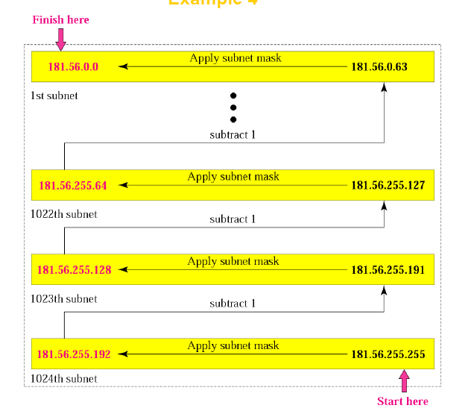

# **Variable Length Subnet Masking (VLSM) in Class-full Addressing**

We can divide a network into 2 halves using subnet.   
We can also divide a network into many smaller sized subnets according to our requirement using VLSM.  
Similar to partitioning 1TB disk in PC into variable size according to our requirement.

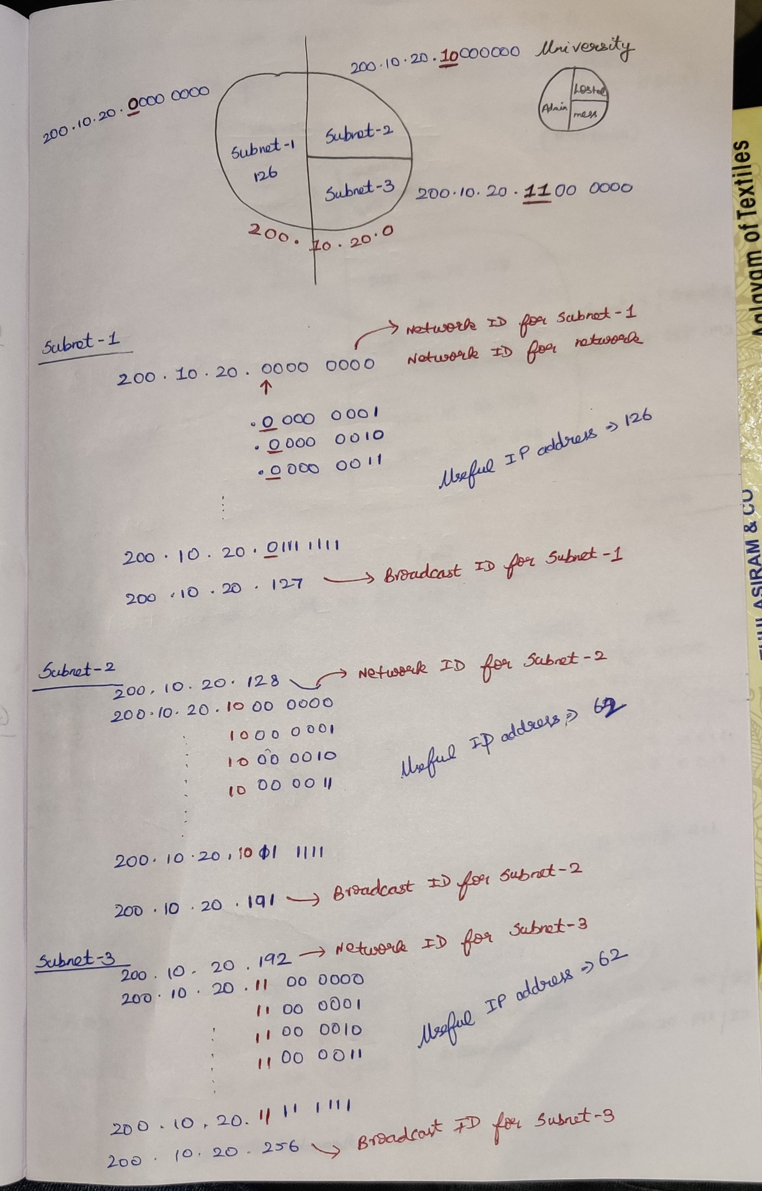

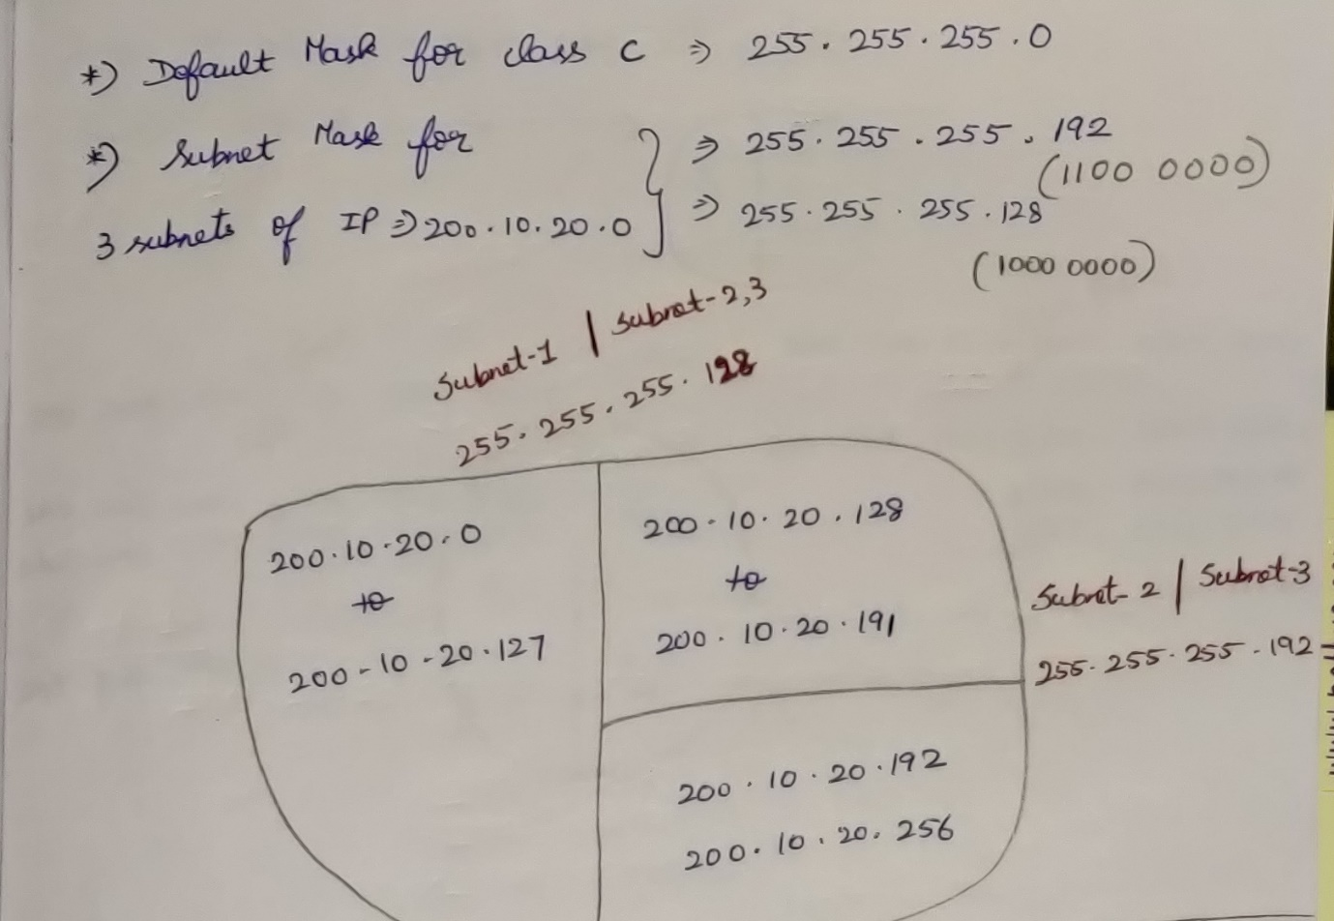

# **Subnet in Classless Addressing / Classless Inter Domain Routing [CIDR]**

## Question-1

## Question-2

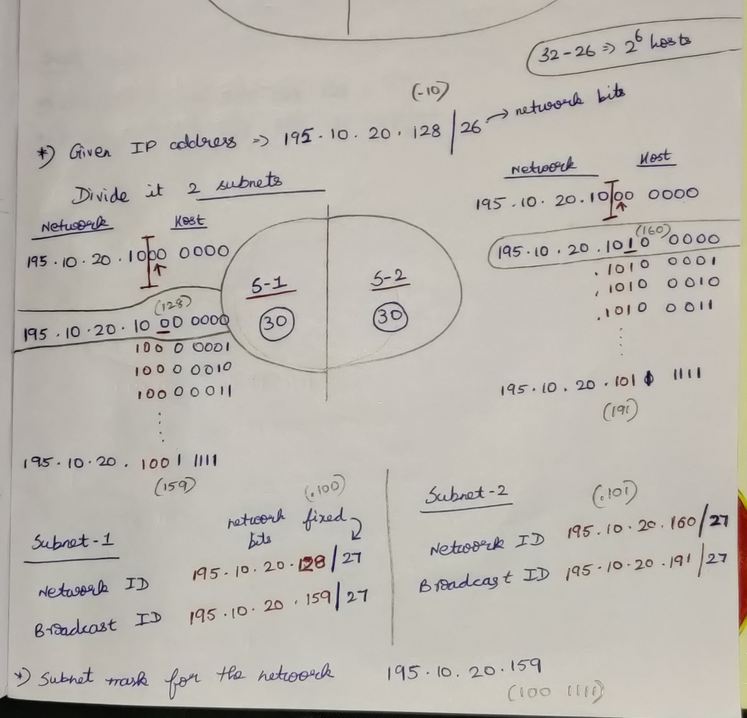

# **Variable Length Subnet Masking (VLSM) in Classless Addressing / Classless Inter Domain Routing [CIDR]**